*Case Study 4.2:* **Low carb lunch** 23 / 24.07.24V.1.1



This paper is about putting the **settings** I had (about 2 years ago) established

**for my entire usual meal spectrum** to the test, with two extremely low-carb lunches.

Method

FCL (no carb inputs, no user boli) with dev variant of AAPS 3.2.0.4 w/autoISF 3.0.1:

Lyumjev 100 (DIA 7h) in Combo pump w/ 10mm Teflon cannula (0-48h)

2 x G6 overlapping (see case study 1.5; sensors used ~ d3 – d15; xDrip, no smoothing in AAPS)

TDD ~ 35 U; profile basal ~ 14 U (0.41…0.75 U/h); profile_ISF 36…44 mg/dl/U; iobTH% = 0.6

Key settings**\*)** for entire meal spectrum (~ 20 … 90 g carb per meal):

SMB size limited at ~ 3.5 U (=2.9 x 120 minutes basal)

autoISFmax = 2.9; SMB delivery ratio = 0.75 fixed

bgAccel_ISF_weight = 0.22; break_weight 0.12; lower:ISF-range_weight 0.7; higher_ISF-range_weight 0.1; pp_ISF_weight = 0.03; dura_ISF_weight 0.8

**\*) Caution: Do not copy settings** from others,

not even for starting your tuning.

Why, see FCL e-book section 4.1.

Fish + veggie lunches managed by autoISF FCL

Settings that were better proven to work for fairly high carb meals (see e.g. Xmas case study 4.3) were put to the test with two (for “my spectrum”) extremely low carb meals.

Two very similar meals were set up for two consecutive days, with an option to lower, on the second day, the iobTH or any of the …_ISF_weights.

As the FCL e-book suggests (in section ), it would be easy to “nudge’’ my FCL for an “outlier” of comparatively low insulin need

* by lowering iobTH% either directly, or indirectly (via low %profile, high TT + exercise button)
* by elevating the effective ISF via lower bgAccel_ISF_weight and / or pp_ISF_weight, and/or via a lower % profile

The first example shown was a cod fillet plus broccoli with herbal crème cheese (12:10)

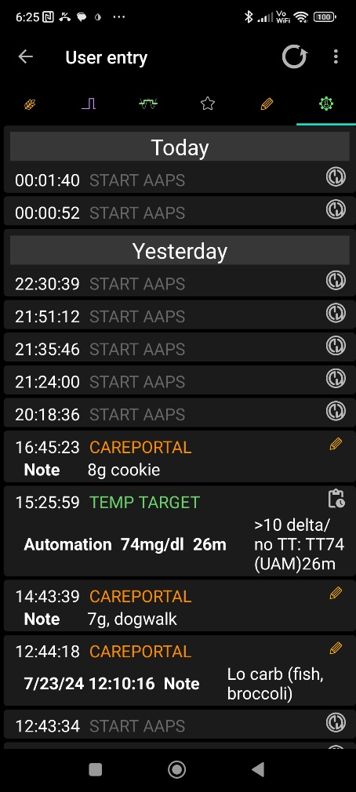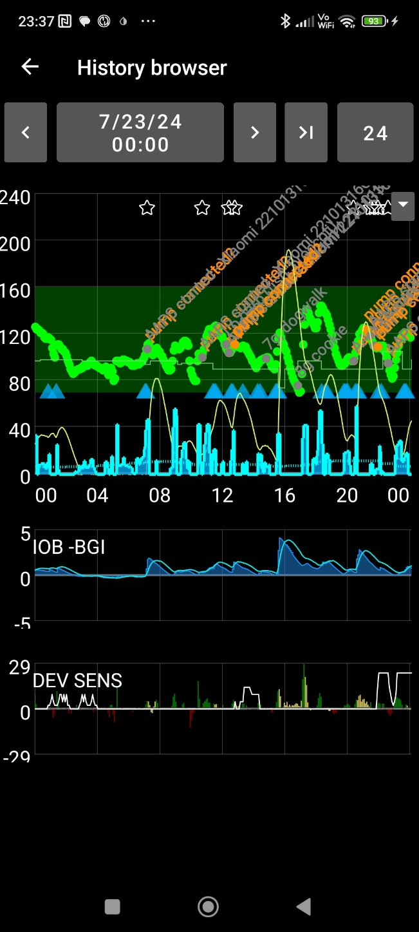

As that went well without any manual intervention…

other than, 2.5 -3 hours after the meal, 2 small cookies before/after a dogwalk

…no settings changes were made for the second meal, which had about same carbs and calories.

Note that iob stayed under 4U all the time, and under 2U in first 2 hours after meal start. That is well below my iobTH of 6 U.

The 2nd meal was (on 24.July’24)

2 small tuna steaks, and black beans (12:50).

Now the initial iob rose stronger (probably because black beans have more carb than broccoli) but remained in the 3 U magnitude in first 2 hours after meal start

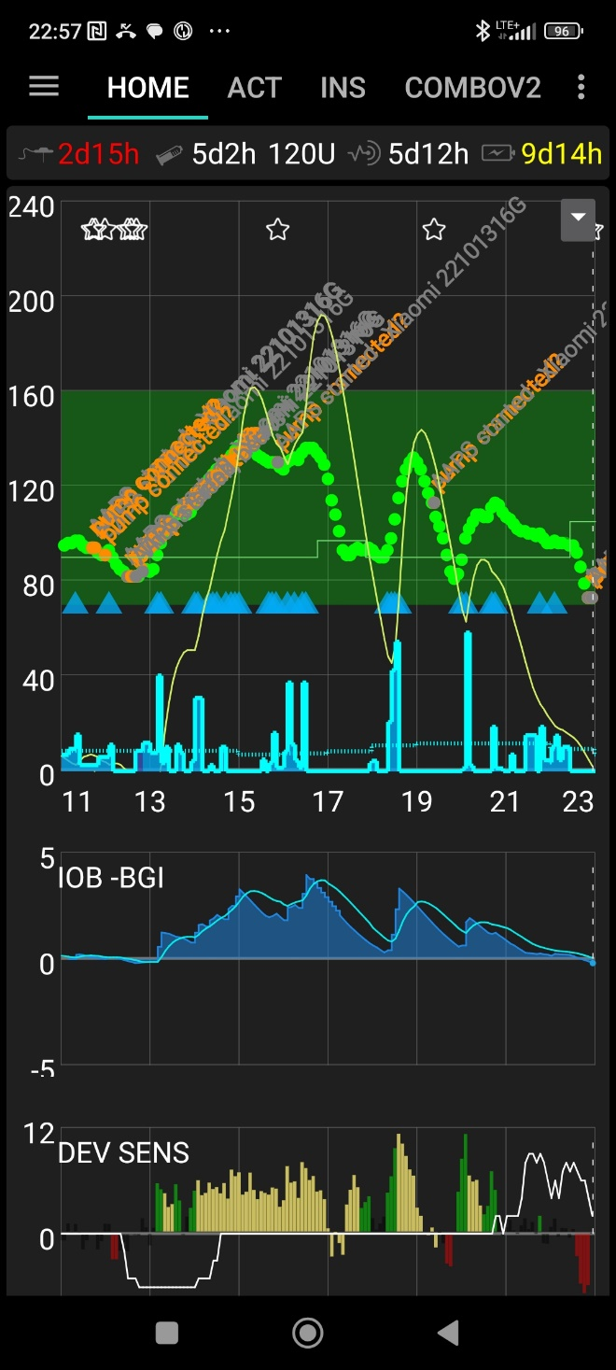

Despite aggressive settings that would quickly deliver big SMBs and exceed iobTH, we experience very moderate SMBs, and no hypo tendency at all.

On both days, 100% TIR was achieved:

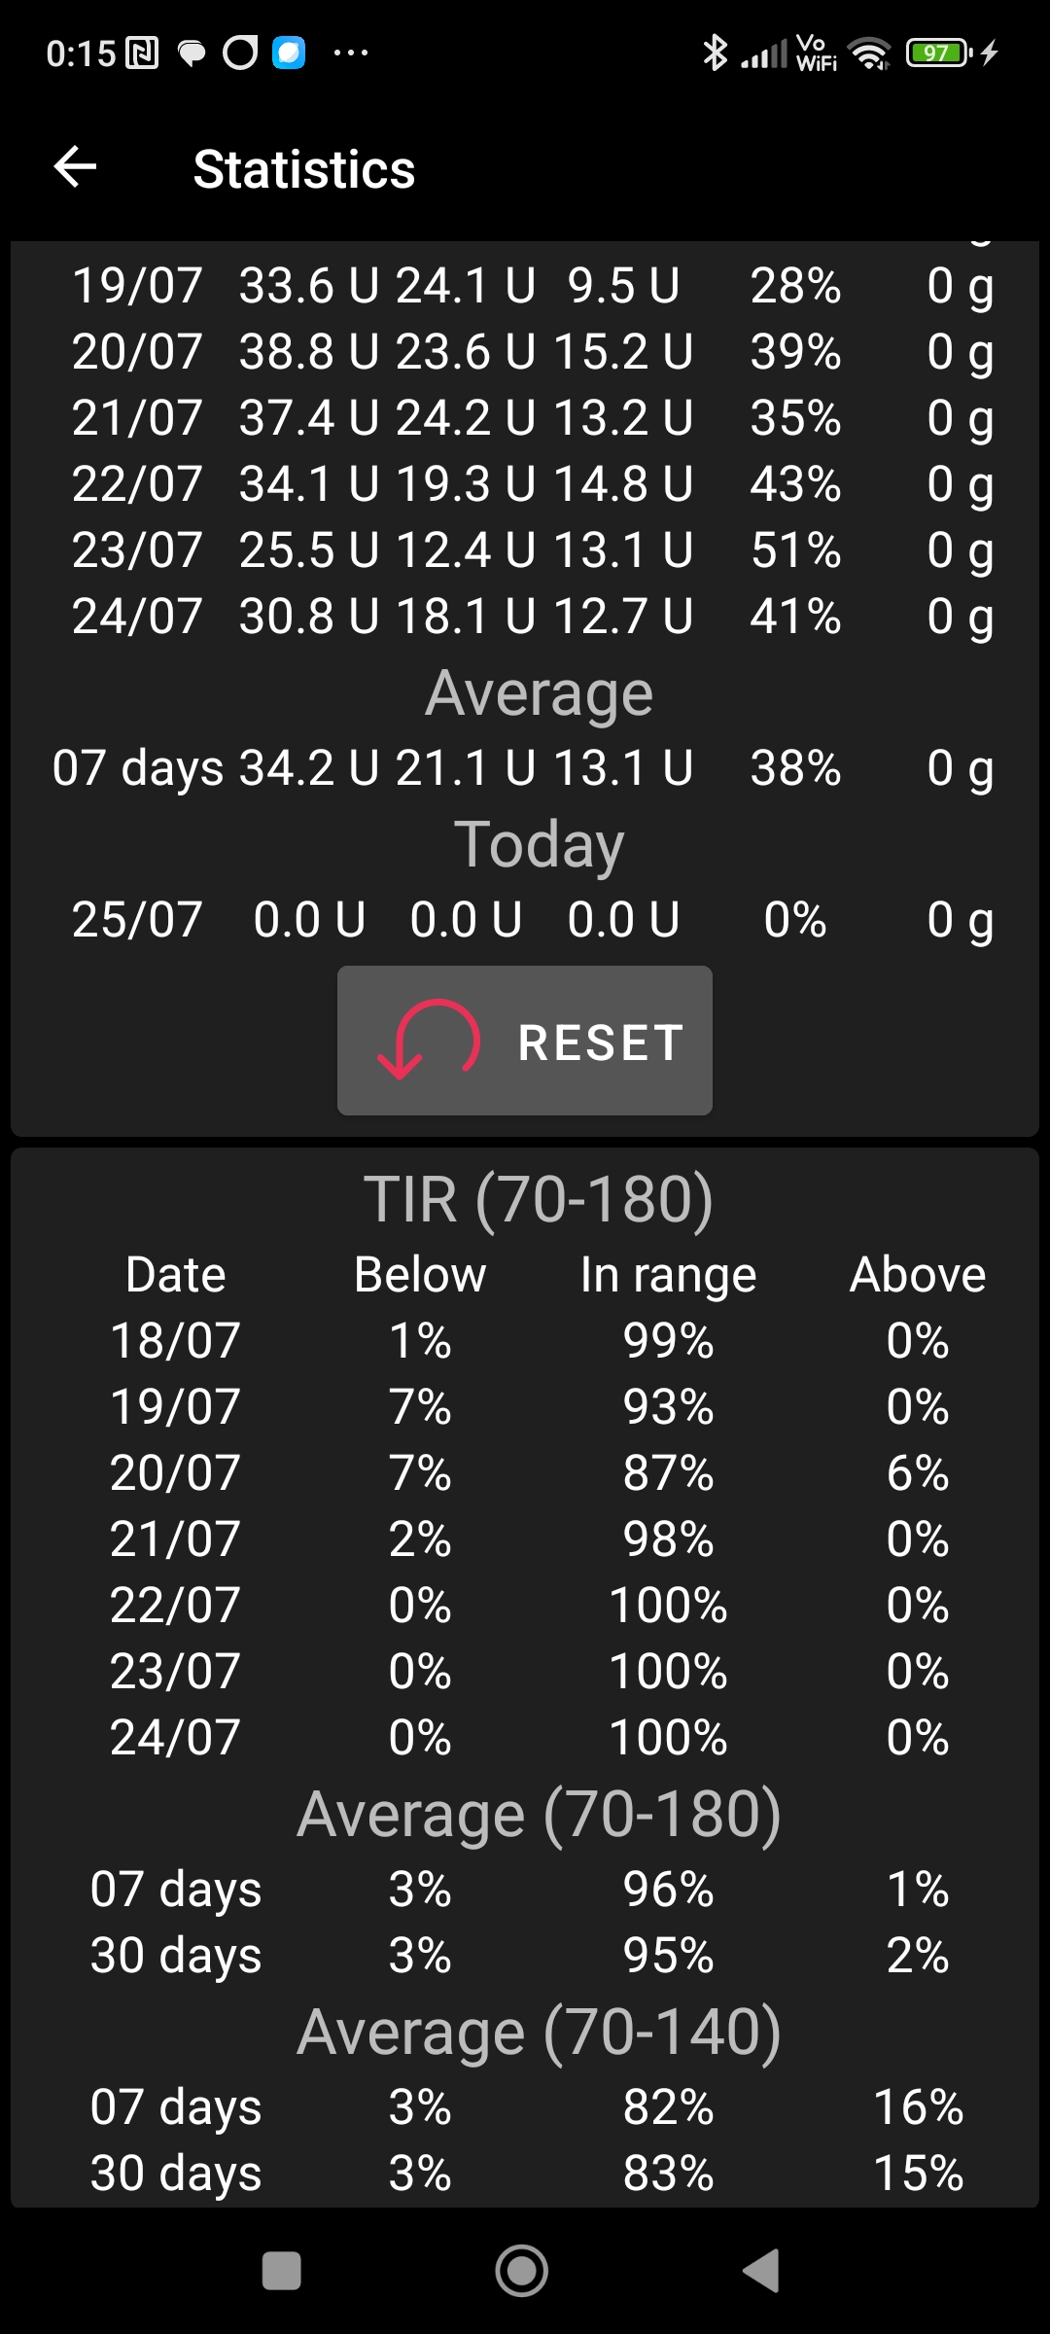

Analysis using the Emulator

Let us have a look how the autoISF factors contributed to provide appropriate iob ( well below iobTH in this low carb case).

Following section 10.2.1 – 10.2.4 of the FCL e-book, analysis of the 2nd meal (24th July):

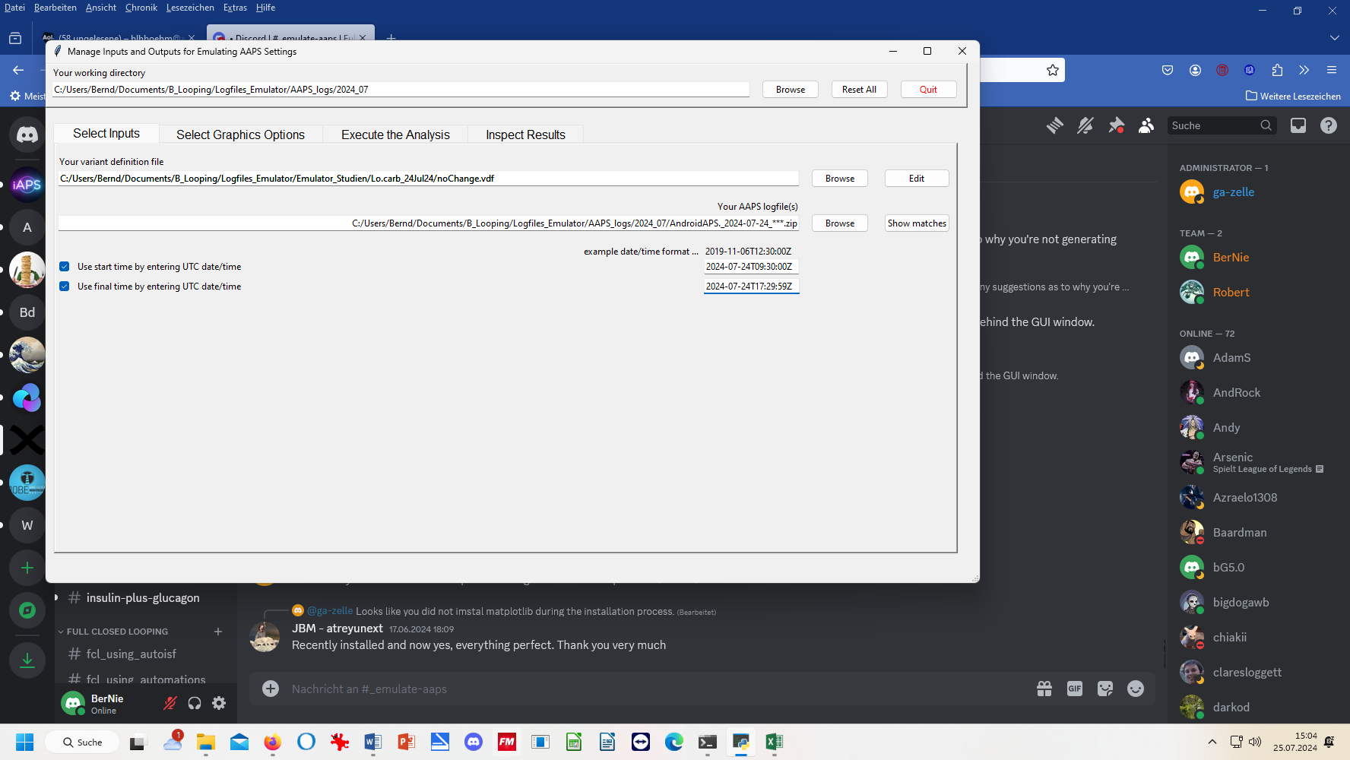

Execute analysis / run emulation / inspect results / csv =>

In column C: AAPS time = UTC time (B) + 2/24 ; format without seconds

Hide not important lines and columns =>

In 3.5 hours after eating, a total of 7.3 U were given as SMBs.

Despite a strong bgAccel_ISF _weight (0.22, *which can result in SMB sizes over 3 U at high carb meals*!), the insulination in the first hour remains moderate. Driven by bgAccel_ISF, only 2.0 U are given in 4 SMBs. BG (E) does not exceed 120 in this time while iob (L) remains under 1.7 U.

There is only a very brief phase, about 1 ½ hours after eating, where for just 10 minutes pp_ISF plays a role to deliver 0.4 U SMB (AO36)

As expected for a low carb major meal, between hour 2 and 4 there is a fairly constant trickle of more carbs being absorbed, while a stream of dura_ISF driven SMBs (A= 40 – AO59) provides a total of 4.9 U of dura_ISF driven SMBs.

This is in line of FCL e-book section 4 where the instructions for initial tuning were to use bgAccel_ISF for rapid initial SMBs suitable for all meals; then pp_ISF for elevating iob over iobTH in high carb meals; and for (s)low carb, we deal with late plateaus via dura_ISF. Interestingly, we do not see an effect of bgBrake_ISF, which was suspected for low carb also in section 4.4

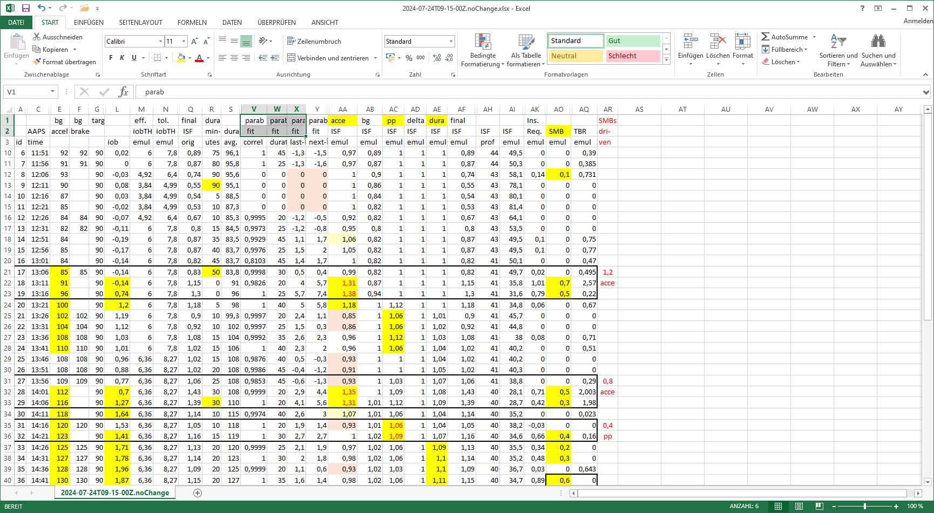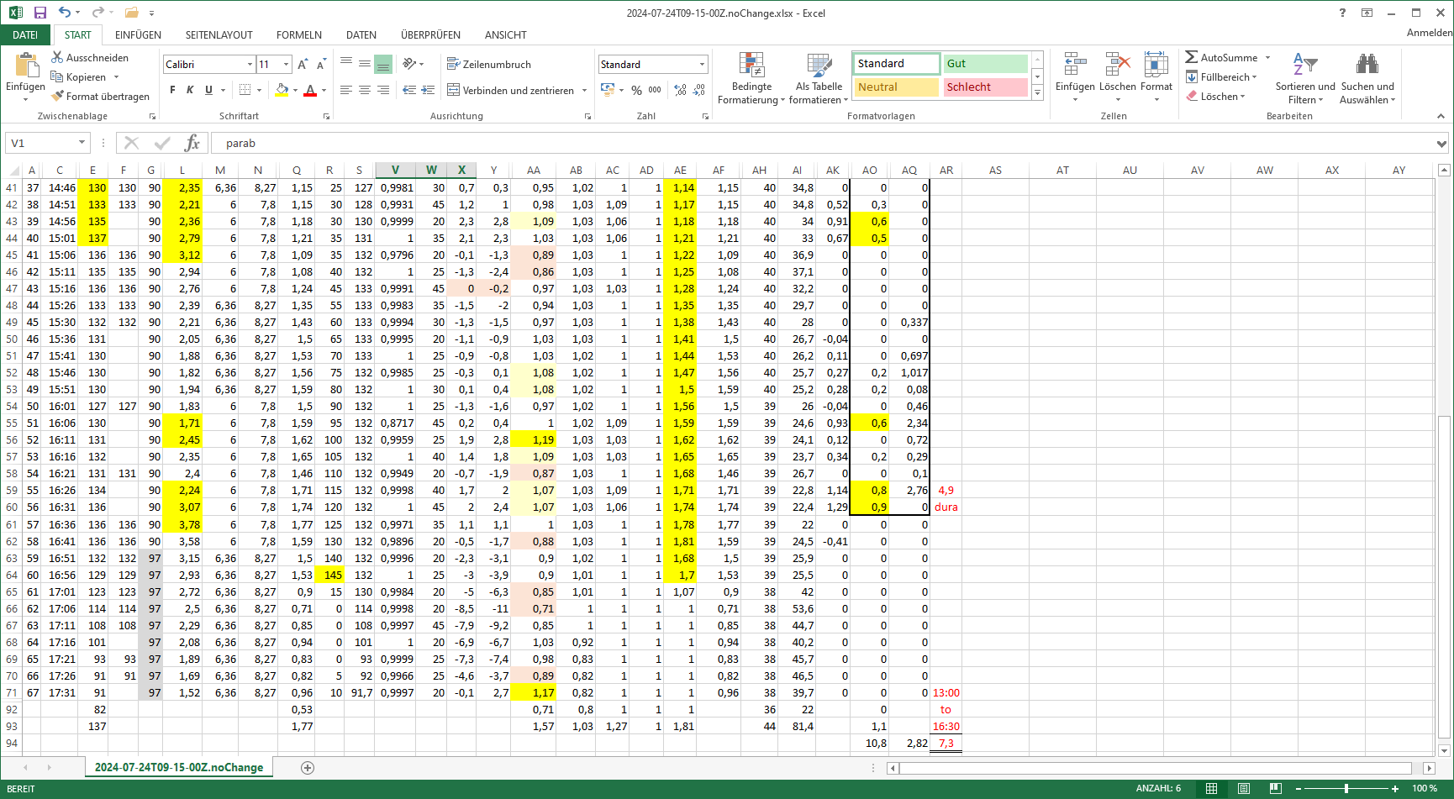

4 h ->

3 h ->

2 h ->

1 h ->

eat ->

Discussion of results

Optimization potential for low carb meals?

The investigated low carb meals were managed very well with the settings that also suit higher carb meals.

*In case there were ideas* for potential further improvements:

* the difference that modified settings *would make* could be analyzed using the Emulator with a “what-if” vdf. See FCL e-book section 10.3 for analysis on your PC, and (especially neat for AAPS:) the *real-time* emulator analysis of a *what-if* question, with speech synthesis on your smartphone, telling you for every loop decision how it would be impacted. See FCL e-book section 11.4
* it must be critically checked whether, after such optimization, *other* meals in your spectrum then might suffer. It is problematic, to fine tune just for one kind of meal.(See FCL e-book section 8, and case study 8.2),
* the user could also choose to create 2 or more differentiated sets of parameters, suited to different eating habits at lunch vs at dinner, for instance, and optimize both independently.

Was I just lucky – Could there be trickier cases?

We know that super big meals do not pose much extra difficulty, if the system was set up for a diet spectrum that included meals with max carb “burn rate” of around 30g/h (ref: Chapter 8 in: <https://github.com/danamlewis/artificialpancreasbook/> -)

The presented case study showed that low carb meals are also easily managed.

**Reduced-size meals (or high carb snacks) that trigger really aggressive first SMBs due to** (a limited amount of) **fast resorbing carbs would be more problematic,** and might require a manual intervention. - See case study 5.2 re. sweet snacks.